UBU Mobile App – Android Installation

Please follow the steps outlined below to install the UBU Test App on your device.

1: type the following URL into the search bar in the browser on your mobile device:

https://mdev.onlineaccess1.com/ngamautotest/apps/4232

2. Once at the screen, you’ll see the following screen. Select 423203 - testonly

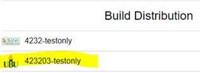

3. Click on the Android tab and version.

4. Select: Tue Sep 15 2020 10:24:24 5.6.18

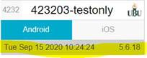

5. Select ARM Build on the next screen.



6. The UBU Test mobile app will then download to your device.

7. You can log in with your TEST credentials to begin testing. If you have forgotten your credentials, they can be found at the top of your ATR workbook.

Please reach out to Beccah if you have any issues installing this app or have any additional questions. Thank you for your help!

